Calculus 2 Lecture 8.1: Solving First Order Differential Equations By Separation of Variables

Separable differential equations:
Order: based on the highest derivative that is in the equation

First order differential equation 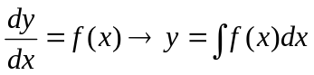
* only for functions of “x”
For both “x” and “y”
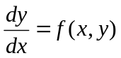, a possible solution is 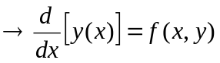
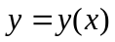 is a solution on an interval.

Will have a solution with one arbitrary constant
This is called a general solution.

For a specific solution, the equation must pass through a specific point 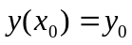

Example
Show that 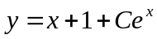 is a solution to 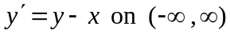
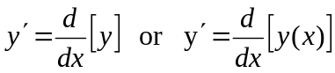
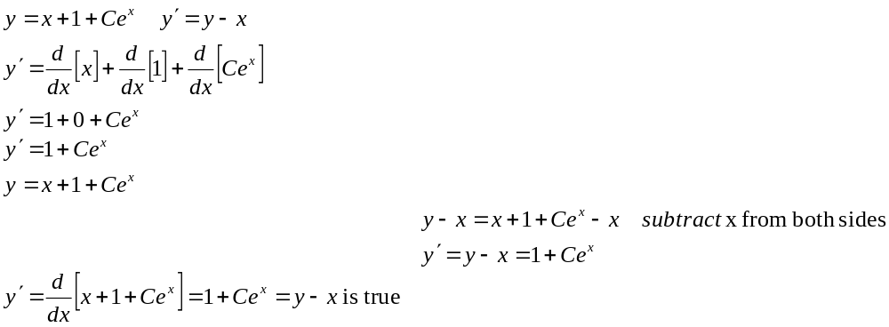

Example
Solve 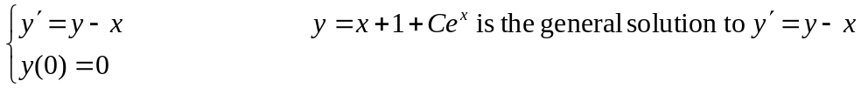
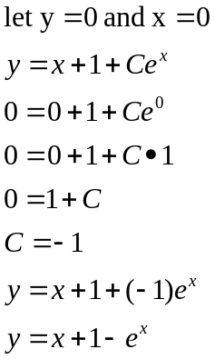

Separable differential equations:
When the differential equation can be written as a product of two functions.
One function in terms of one variable and the other function in terms of the second variable.
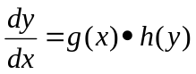 OR 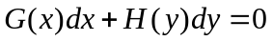

How to solve a differential equation by separation of variables.
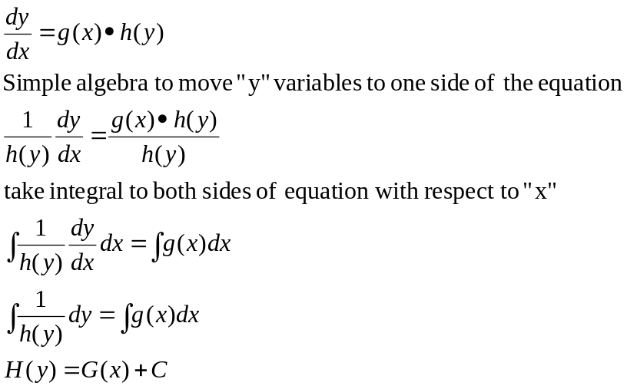

Example
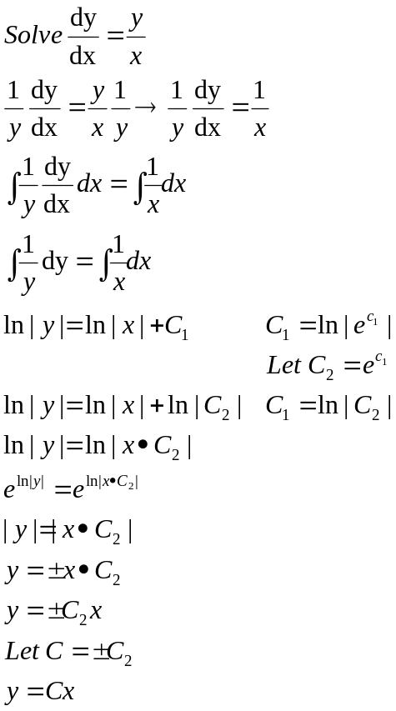

Example
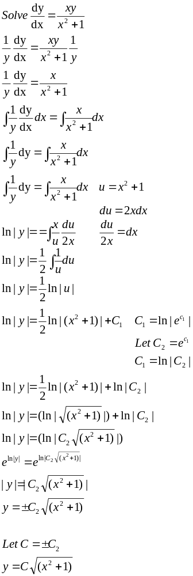
Example
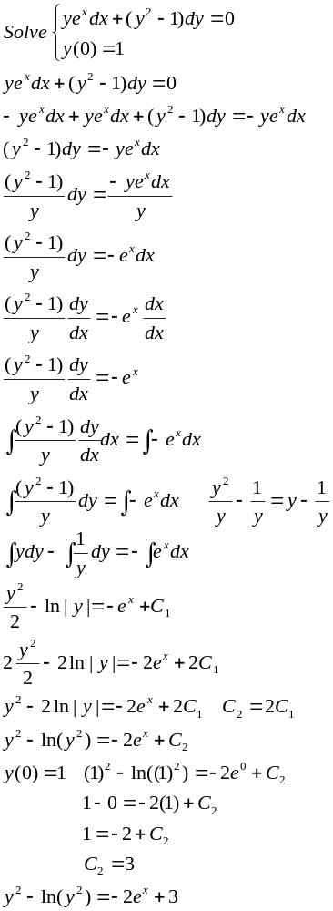
Natural growth and decay.
Growth or decay at a rate proportional to the size of a population.
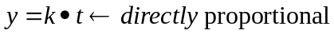
Rate of change would be first derivative
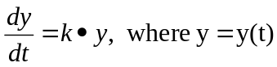 derivative of population with respect to time
When k>0 population growing
When k<0 population is decaying

Example
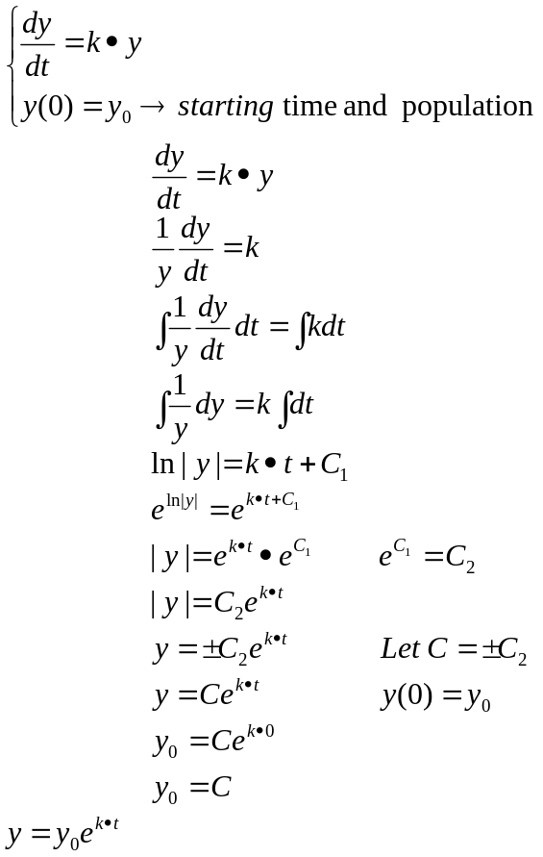

Example
Growth of bacteria is proportional to its population.
Initially 600 bacteria are present, after 3 hour 10,000 bacteria are present

Find the number of bacteria after “t” hours.
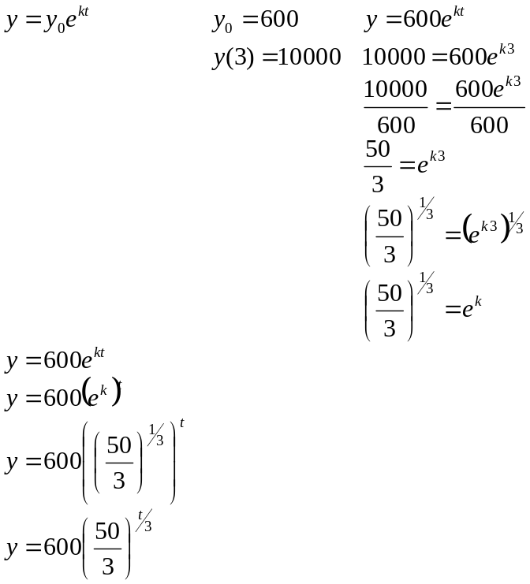
How many bacteria is there after 5 hours?
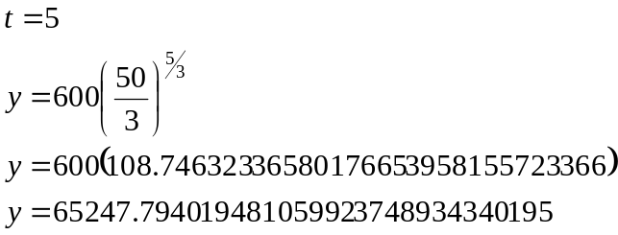

When will the bacteria reach 24000 ?
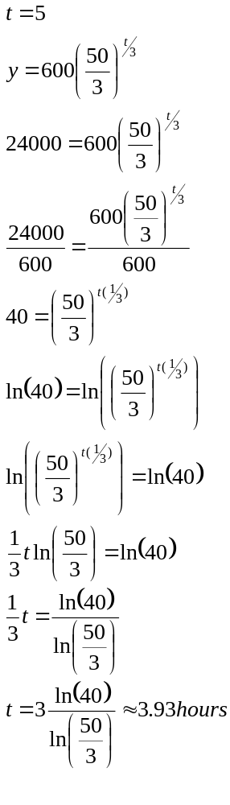
Example
Suppose the half-life of compound “A” is 1602 year, we have 100mg to start.
Find amount after “t” years 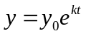
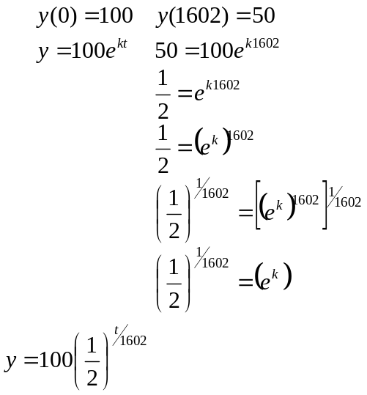

Find amount of compound left after 1000 year?
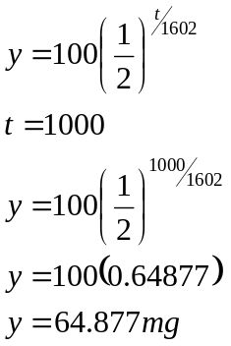

How long will it take to get to 40mg
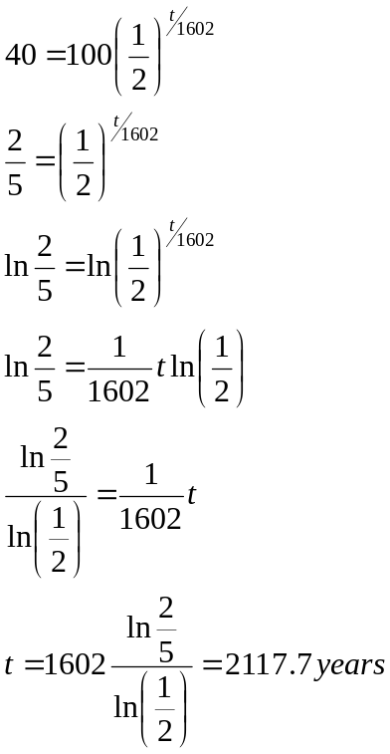
Law of cooling.
A body cools proportional to the difference between the body and the ambient temperature.

Example
A turkey is taken out of an oven at 225 degrees after 20 minutes the temperature was 185 degrees
The ambient temperature was 70 degrees
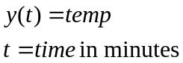

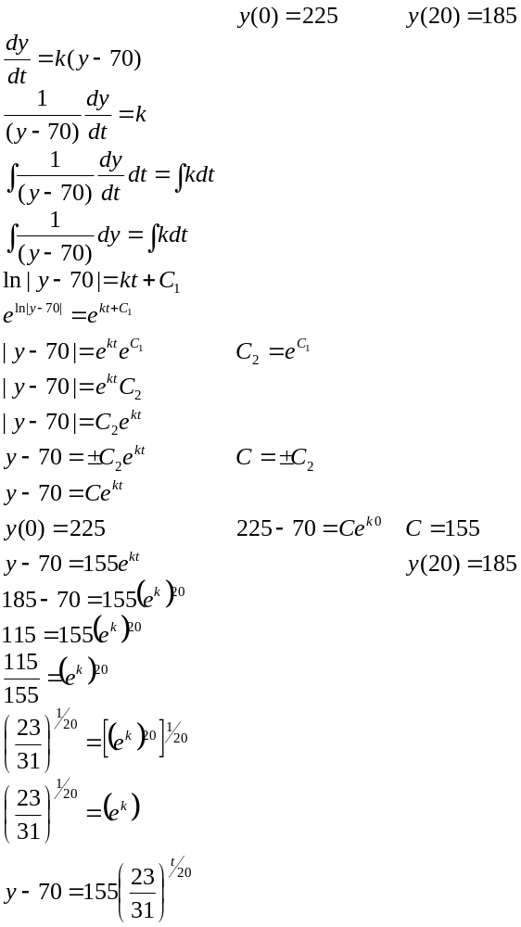
What is the temperature of the turkey after 30 minutes
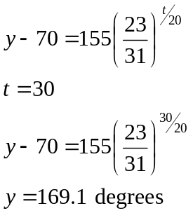

How long does not Mr. Leonard wait to cut the turkey so he will not burn hands.
